 | 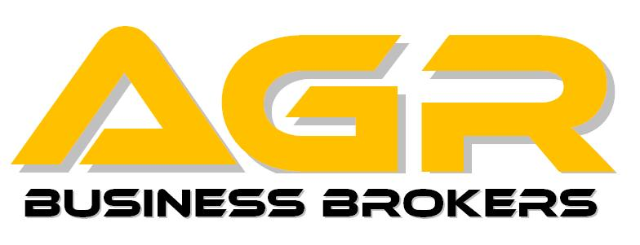 | 36 Farview Terrace  Paramus, NJ 07652  Tel: (800)845-2121  Fax: (201)845-3594  Info@AGRbrokers.com

NON-DISCLOSURE / NON-CIRCUMVENTION AGREEMENT

Non-Disclosure Agreement: The undersigned Prospective Buyer(s) agrees that in connection with any property and/or business introduced to Prospective Buyer(s) by All Gold Realty, Inc. / AGR Business Brokers (hereinafter “AGR Brokers”): (1) Prospective Buyer(s) will not disclose to any party who has no need to know, information concerning said businesses / properties, that is including, but not limited to trade secrets, products, services, prices, suppliers, financial statements and reports, operations, client names, sales techniques, production methods, ideas, inventory list, concepts and/or product designs; and (2) Prospective Buyer(s) will not, directly or indirectly, solicit, employ, call upon, sell to, divert, or take away any of the customers, disclose business opportunity, suppliers, endorsers, advertisers, contractors, and/or employees of the introduced properties and/or businesses. In the event, Prospective Buyer(s) violates this agreement, Prospective Buyer(s) will be personally liable to the owner of said introduced business to the extent that the owner sustains actual loss/damages from said violation. (3) The Prospective Buyer(s) also agrees to indemnify AGR Brokers in the event any action is brought by the owner of said introduced business against AGR Brokers as a result of a violation of this Agreement by the Prospective Buyer(s).

Non-Circumvention Agreement: In connection with any property and/or businesses introduced to the undersigned Prospective Buyer(s) by AGR Brokers the Prospective Buyer(s) agrees: (1) not to acquire any of the introduced properties and/or businesses, whether directly or indirectly, by purchase, lease, lease assumption stock transfer, license assignment, or any other means, unless AGR Brokers receives the agreed upon commission from the listing party; (2) that circumvention of this Agreement, through such acquisition in any manner will cause the undersigned to be personally liable to AGR Brokers, Inc. for the agreed-upon commission with the listing party or Twelve(12%) percent of the purchase price of the business / property, whichever is more; (3) That none of the introduced properties and/or businesses have been offered by another broker; (4) not to take possession of any introduced property and/or business unless AGR Brokers first receives a copy of the contract of sale for said property / businesses. Representations made by seller are not guaranteed and Prospective Buyer(s) will not hold AGR Brokers responsible for any misrepresentations(s) made by the seller, lessor, or any third party. (5) This Agreement stands for all Properties and/or Businesses introduced by AGR Brokers that have been either listed on the attached sheet plus any other businesses and/or properties introduced. Introduction means AGR Brokers had provided information and/or shown property.

DEFAULT: In the event Prospective Buyer(s) violates any of the terms and conditions of the Non-Disclosure and Non-Circumvention Agreements, Prospective Buyer(s) will be liable for all cost of action, including reasonable attorney’s fees. Prospective Buyer(s) also consents to the jurisdiction of the State of New Jersey, County of Bergen, to adjudicate any dispute arising hereunder.

I (We) have read and understand the contents hereof, and have received a copy of same. This agreement expires twenty-four (24) months from the date listed below.

Print Prospective Buyer(s) Legal Name(s) | Signature(s) | Date

Address | City | State | Zip Code
Accepted by on behalf of AGR Brokers.

CONTACT INFO:
PLEASE NOTE THIS PAGE MUST BE FILLED OUT COMPLETELY BEFORE ANY INFORMATION IS RELEASED

Home tel | business tel |  | fax |  | mobile |  | email
( ) - | ( ) - |  | ( ) - |  | ( ) -
iNTRODUCED THROUGH
MAXIMUM PRICE |  | $ |  | dOWN PAYMENT |  | $
additional details:
special requirements

Areas interested in
Please be prepared to fill out a financial statement upon request by AGR Brokers
indicate properties interested in:
Hotel | Conv Store | Gas Station | Liquor Store | Invstmnt Property
Land | Office Space | Retail Space | Warehouse | Dry Cleaners/Laundromat
Franchised Business (Please describe) :
Other: (Please describe) :
property list:
List includes properties wherein AGR brokers has provided information or shown properties and/or businesses;
Additional sheets may be added as needed and will become part of this agreement.
The following list details businesses introduced along with any other property and/ or business(es) shown by AGR Brokers/ All Gold Realty, Inc.
PLEASE NOTE: YOU ARE NOT PERMITTED TO SPEAK WITH THE OWNER, EMPLOYEES, OR CUSTOMERS AT ANY OF THE BUSINESS(ES) INTRODUCED TO YOU BY AGR BROKERS!
Business Name: | Address: | Broker: | Dated:

